Workshop: Petstagram
In this module, we're set to develop a comprehensive Django project named "Petstagram." This project encompasses various features, including user registration, login, and logout capabilities. Users can add pets to their profiles, upload photos of their pets, and explore a collective display of all pet photos. Additionally, users can delve into photo details, express likes, and provide comments. The functionality extends to enabling users to edit and delete their uploaded photos and pet information.
The full project description can be found in the Workshop Description Document.

Workshop - Part 1.1

Setup
Let us start by creating the project:
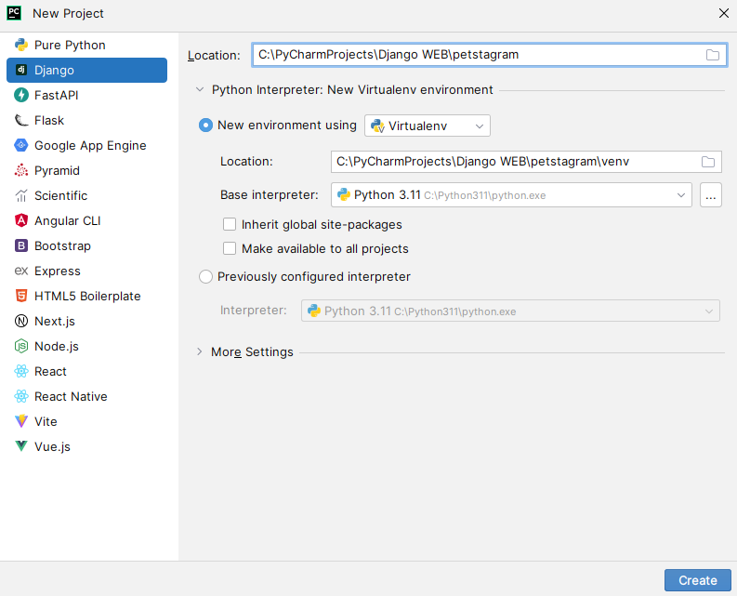
As we get started, we can launch the applications with the command: "python manage.py runserver" in the Terminal.
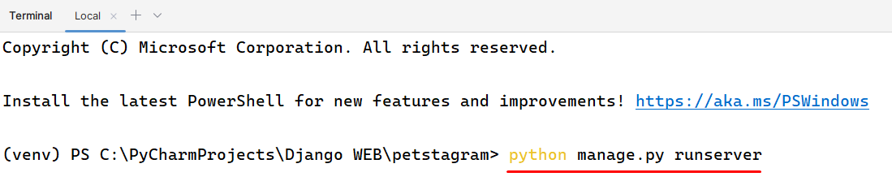
Afterward, just click on the given link to access them.
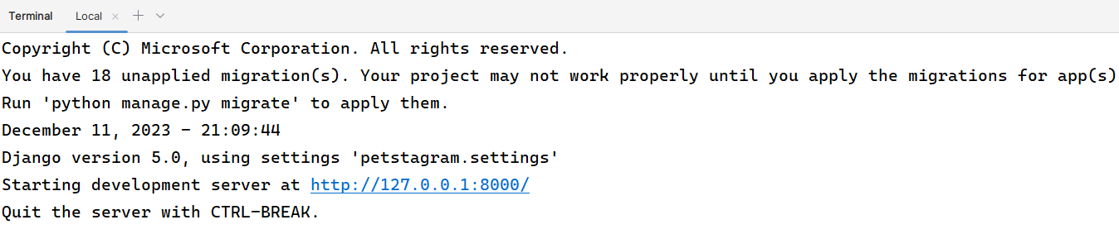
You should see the autogenerated Django "Congratulations" page: 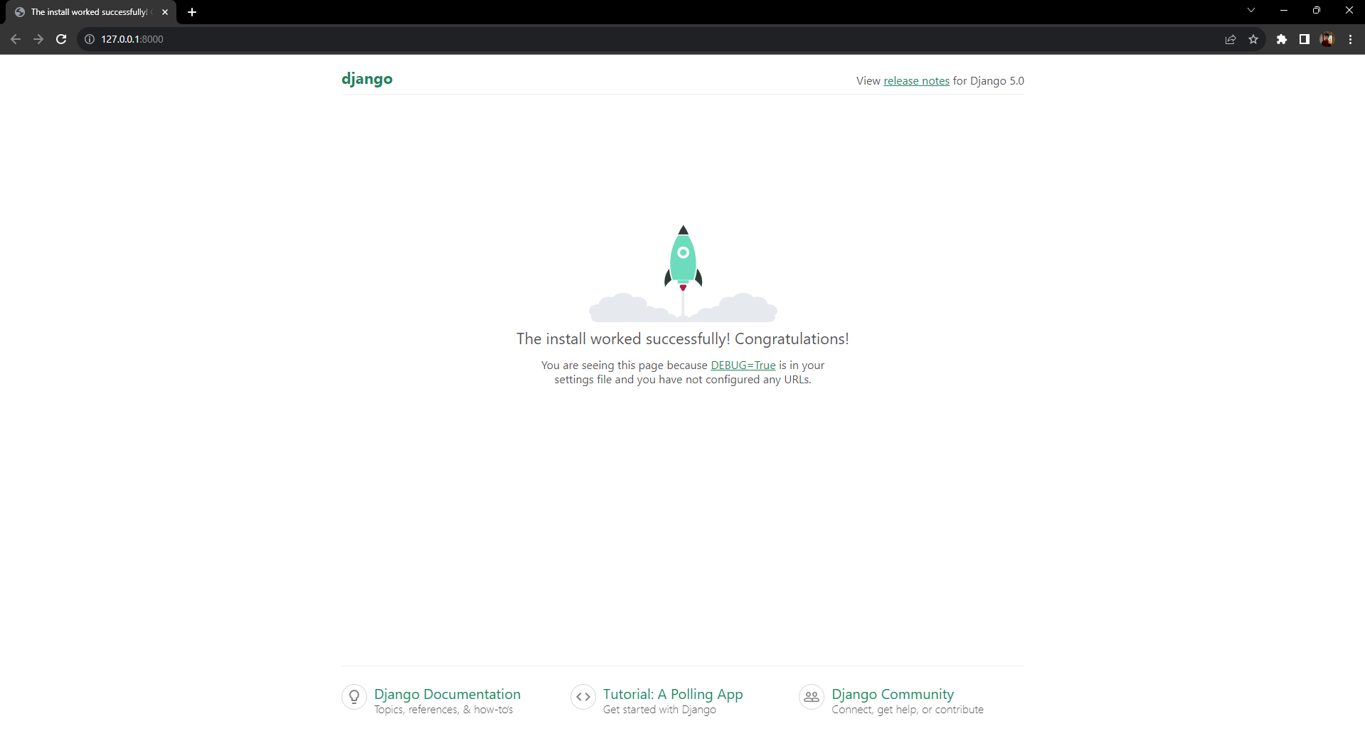

Creating the Apps
Now, we will establish the applications that will be integral to our project. These applications are named "photos", "pets", "accounts", and "common". Each of them will encompass various components of our project.
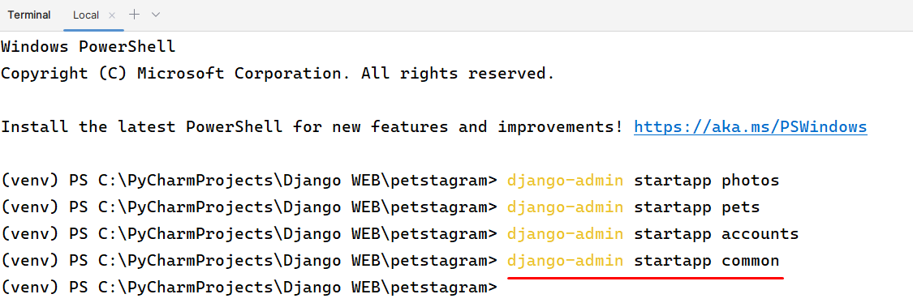
For clarification, move the created apps inside the project:
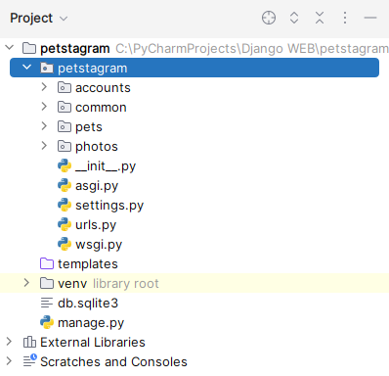

Configurations
We need to add the apps we just created in the INSTALLED_APPS setting:
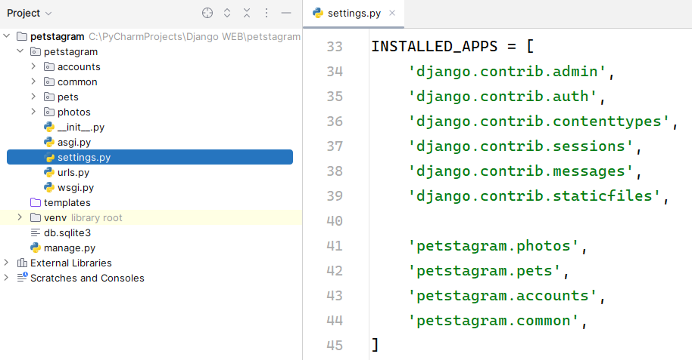

Workshop - Part 1.2

Adding the Templates
The subsequent task involves us transferring the HTML files into the "templates" folder. To enhance clarity, we should consider organizing the templates into different directories based on specific groups. The only template we should not move is the "404.html". By default, it should be put inside the project "templates" directory on the "manage.py" level.
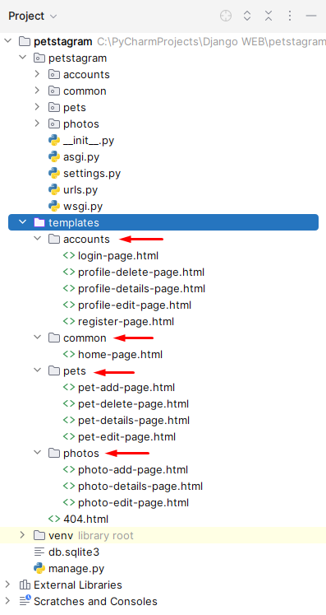

Adding the Static Files
Add a directory called "static" on the "manage.py" level:
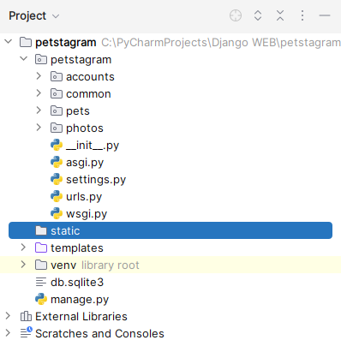
Add the provided folders ("css" and "images") to the directory. Next, Django should look for additional static files, like CSS or JavaScript, outside of the app-specific "static" folders, therefor we need to rewrite our settings.py.
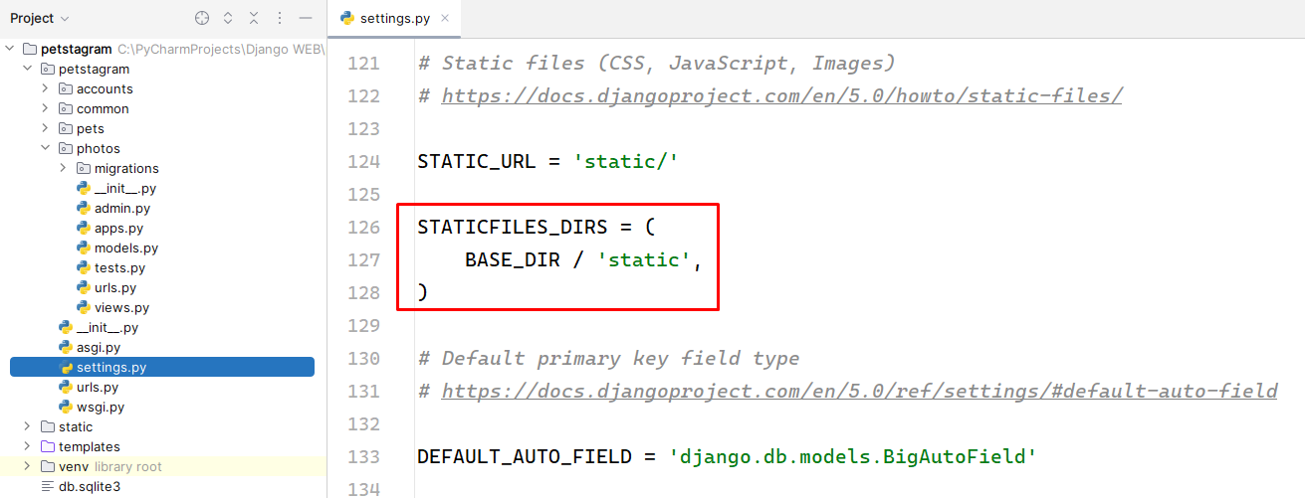

Adding the URLs (paths)
We want to load each template in the browser using a concrete path - each app should load its templates. To do that, we should add "urls.py" files in each app:
Note: In this instance, we are exclusively showcasing the URLs within the "photos" application. Ensure to replicate this process for all other applications by incorporating their respective URL configurations.
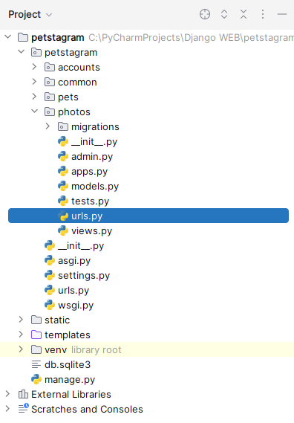
Before configuring the "urls.py" files in each app, it is essential to set up the main URLs, often found in the project's main "urls.py" file. This ensures that the overall URL configuration is established before delving into the app-specific configurations:
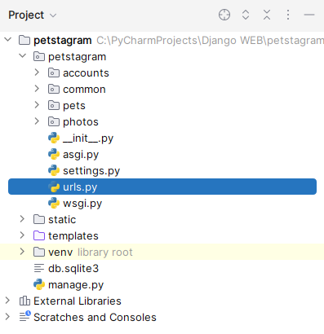
Next, we can start including them in our main project "urls.py" file. We should import the "include()" function from the Django urls module, and then we can use the "path()" function to construct paths that lead to the "urlpatterns" of each app.
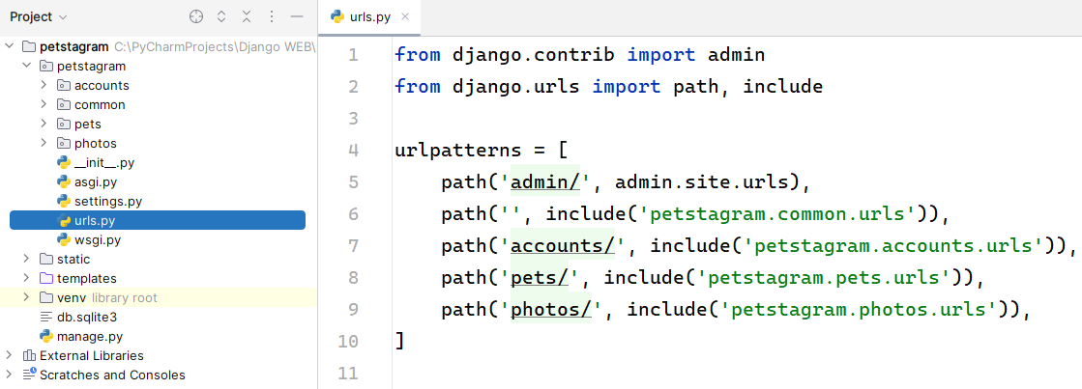
Next, in each app create an urls.py file. Then, create paths connected to each view we will configure. Let us start by adding the following paths in the accounts app:
Application "accounts" paths:
- Registration Page: http://127.0.0.1:8000/accounts/register/
- Login Page: http://127.0.0.1:8000/accounts/login/
- Profile Details Page: http://127.0.0.1:8000/accounts/profile/<int:pk>/
- Profile Edit Page: http://127.0.0.1:8000/accounts/profile/<int:pk>/edit/
- Profile Delete Page: http://127.0.0.1:8000/accounts/profile/<int:pk>/delete/
To do that, we should create a "urlspatterns" tuple in the "accounts/urls.py" file:
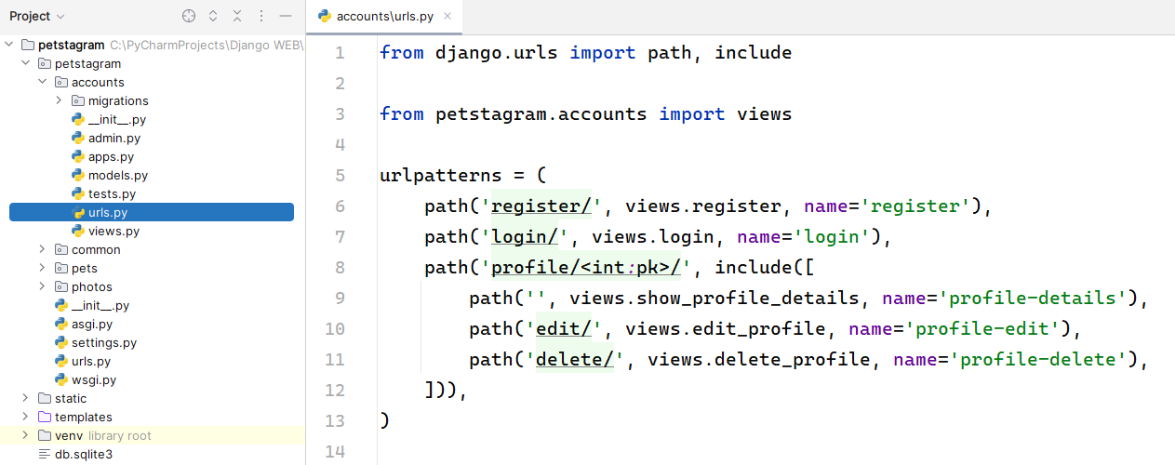
The same configuration should be added to the other apps for the following URLs:
Application "common" paths:
- Home Page: http://127.0.0.1:8000/
Application "photos" paths:
- Photo Add Page: http://127.0.0.1:8000/photos/add/
- Photo Details Page: http://127.0.0.1:8000/photos/<int:pk>/
- Photo Edit Page: http://127.0.0.1:8000/photos/<int:pk>/edit/
Application "pets" paths:
- Pet Add Page: http://127.0.0.1:8000/pets/add/
- Pet Details Page: http://127.0.0.1:8000/pets/<str:username>/pet/<slug:pet_slug>/
- Pet Edit Page: http://127.0.0.1:8000/pets/<str:username>/pet/<slug:pet_slug>/edit/
- Pet Delete Page: http://127.0.0.1:8000/pets/<str:username>/pet/<slug:pet_slug>/delete/

Adding Views
As you see, we have not created the views so far, and they appear to be missing in the "urls.py" file. Now, we will start adding them to the "views.py" file for each app. For example, we will use the names of the views created in the "accounts/urls.py" file to create the views in the "accounts/views.py" file:
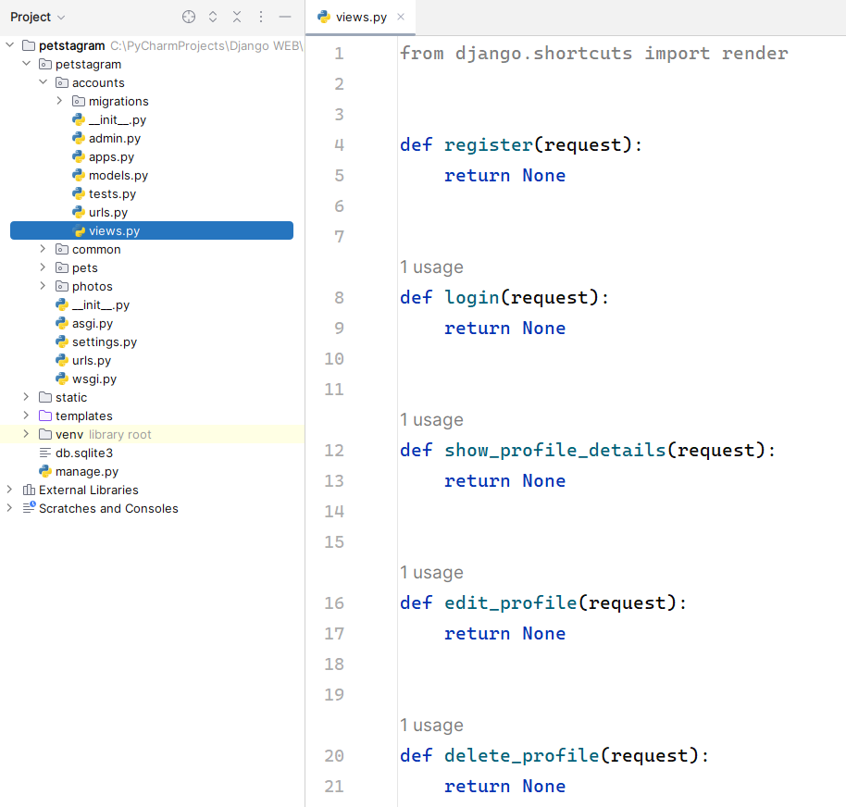
Each view should receive a request and return a response. The response we want to return is a rendered HTML page we already added to our "templates/accounts" directory. Let us write a render function for each view to return:
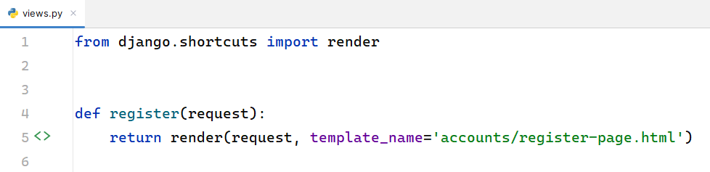
The first parameter the "render()" function accepts is the given request. Next, we could pass the template we want to be shown when loading the specific path. In this case, when we load http://127.0.0.1:8000/accounts/register/ we should see the register-page template:
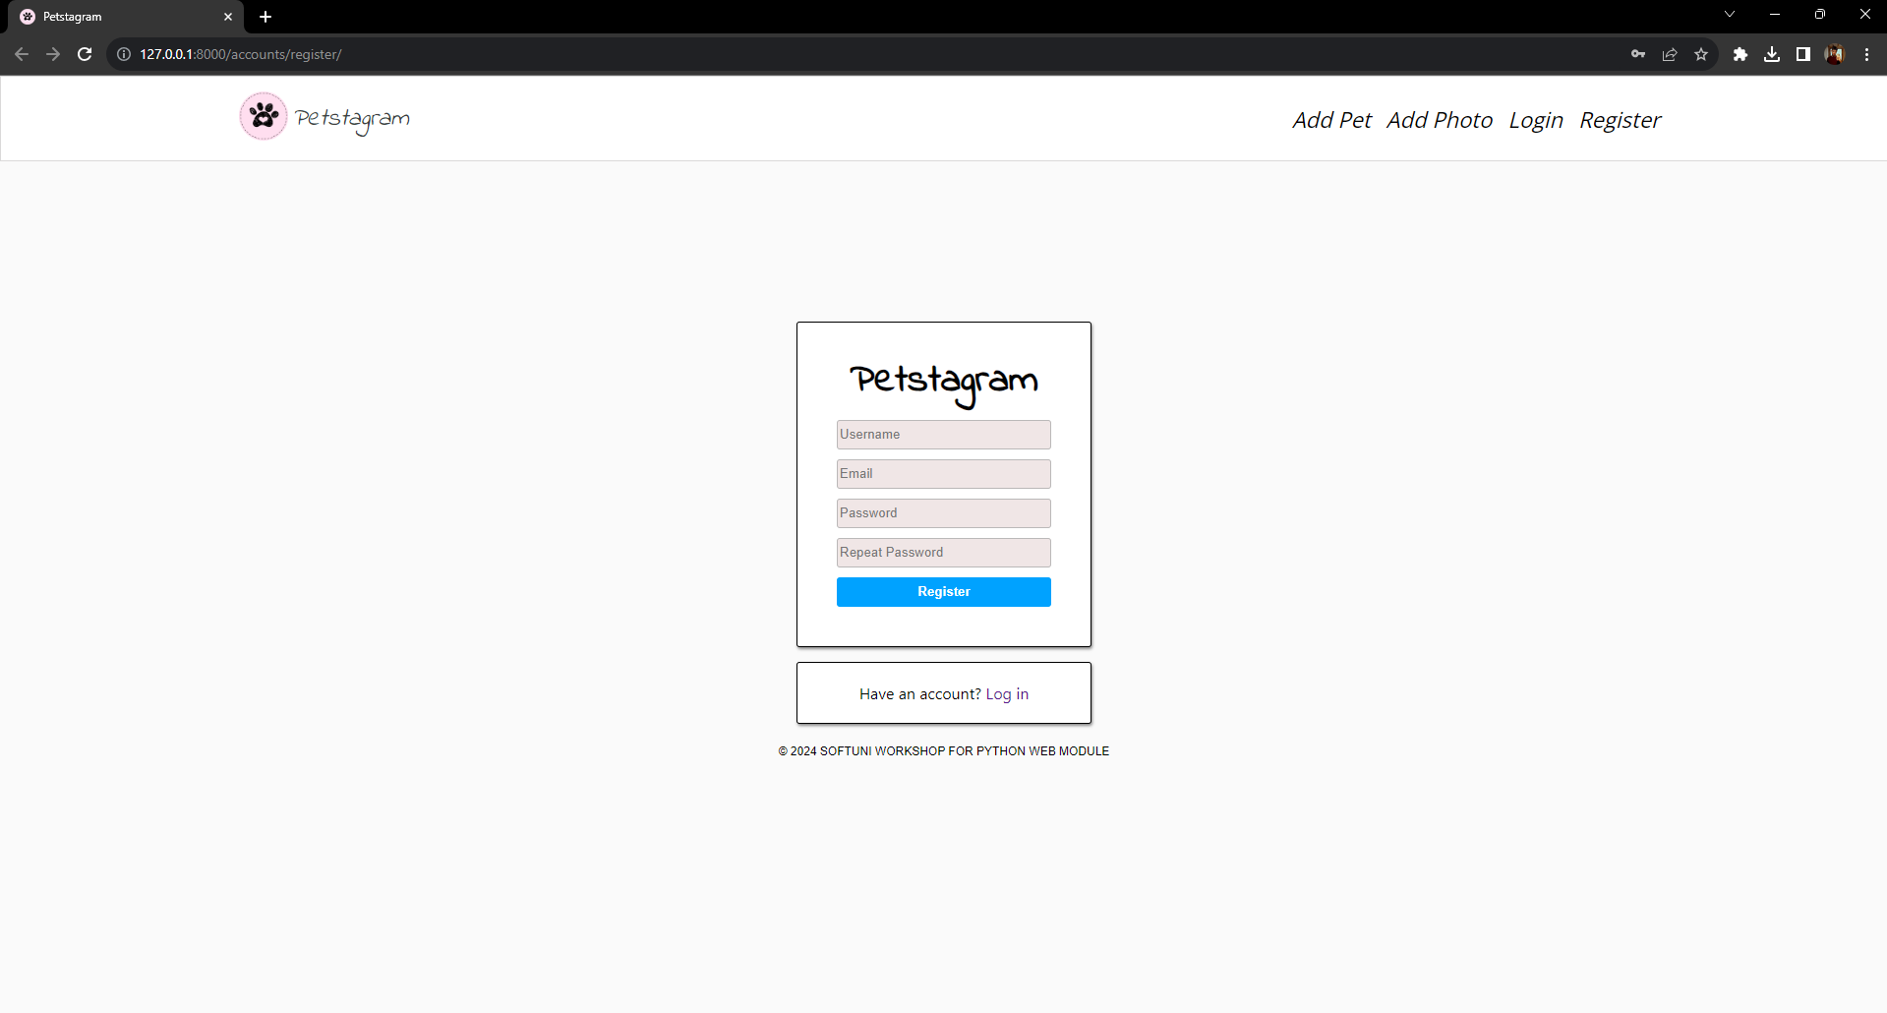
In the same way we can create all views in the project.

Workshop - Part 1.3

Adding Static Files in Templates
Django uses special template tag to tell the template engine to use the files from the static folder. In each template where we will use static files this tag should be added. For example, in the "accounts/login-page.html" template it will look like this:
{% load static %}
<!DOCTYPE html>
<html lang="en">
<!-- Starts Head Section -->
<head>
<link rel="stylesheet" href="{% static 'css/styles.css' %}">
<link rel="icon" type="image/x-icon" href="{% static 'images/free-30-instagram-stories-icons23_122570.png' %}">
<link rel="stylesheet" href="https://cdnjs.cloudflare.com/ajax/libs/font-awesome/6.5.1/css/all.min.css"
integrity="sha512-DTOQO9RWCH3ppGqcWaEA1BIZOC6xxalwEsw9c2QQeAIftl+Vegovlnee1c9QX4TctnWMn13TZye+giMm8e2LwA=="
crossorigin="anonymous" referrerpolicy="no-referrer"/>
<title>Petstagram</title>
</head>
<!-- End Head Section -->
<!-- Starts Body Section -->
<body>
<!-- Starts Header Section with Navigation Bar -->
<header>
<nav class="navbar">
<div class="container">
<div class="logo">
<!-- Link to Home Page -->
<a href="#">
<img width="50px" src="{% static 'images/free-30-instagram-stories-icons23_122570.png' %}" alt="img1">
</a>
<!-- Link to Home Page -->
<a class="home" href="#">
<i>Petstagram</i>
</a>
</div>
<div class="nav-links">
<ul class="nav-group">
<li class="nav-item">
<!-- Link to Add Pet Page -->
<a href="#">
<i>Add Pet</i>
</a>
</li>
<li class="nav-item">
<!-- Link to Add Photo Page -->
<a href="#">
<i>Add Photo</i>
</a>
</li>

...

404 Template
When we load the static files in the template, it should look like this:
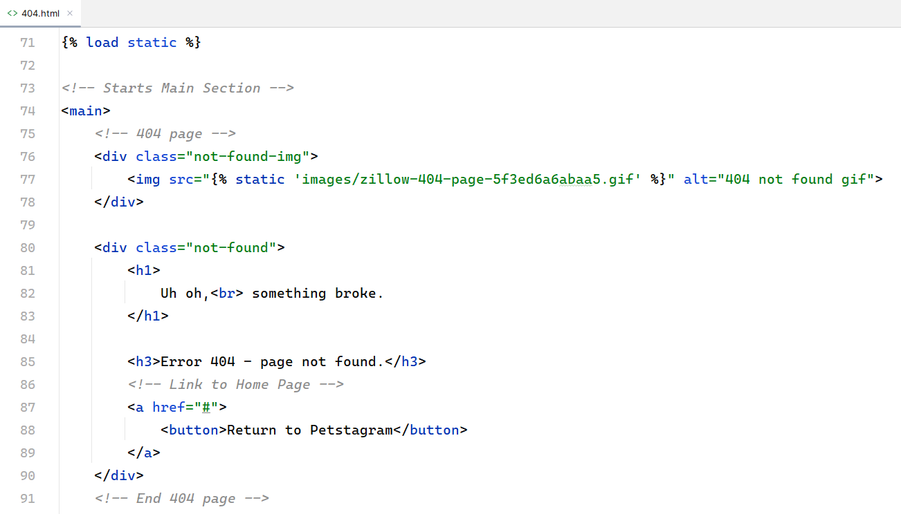

Adding Hyperlinks in Templates
The only thing needed to be done here is to add a hyperlink that will lead to the Petstagram home page. We can use the url tag (you do not need to configure all hyperlinks; we will do it in the next workshop when we make template inheritance):
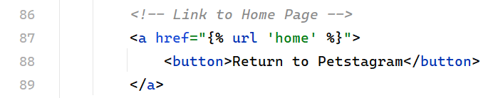

Testing 404 Template
The page is only visible when DEBUG setting is set to False. Let us use "*" syntax to allow all hosts to reach the app:
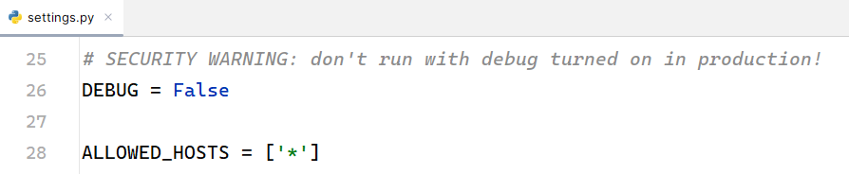
When you start the development server and try to reach an invalid page you should see the 404 Template:
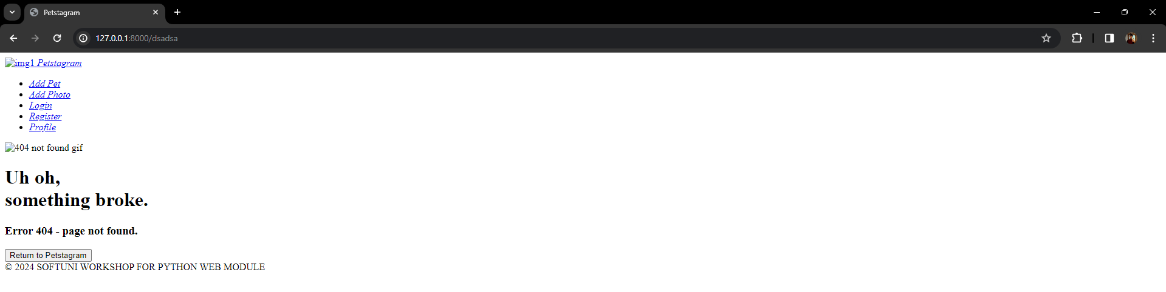
Notice that the HTML is loaded, but the CSS is NOT loaded. With debug turned off Django will not handle static files for us. The meaning of DEBUG set to False is that the app is in production, so the production web server should take care of the style. To test in DEBUG False mode locally, we can run the development server with a specific command: "python manage.py runserver --insecure":
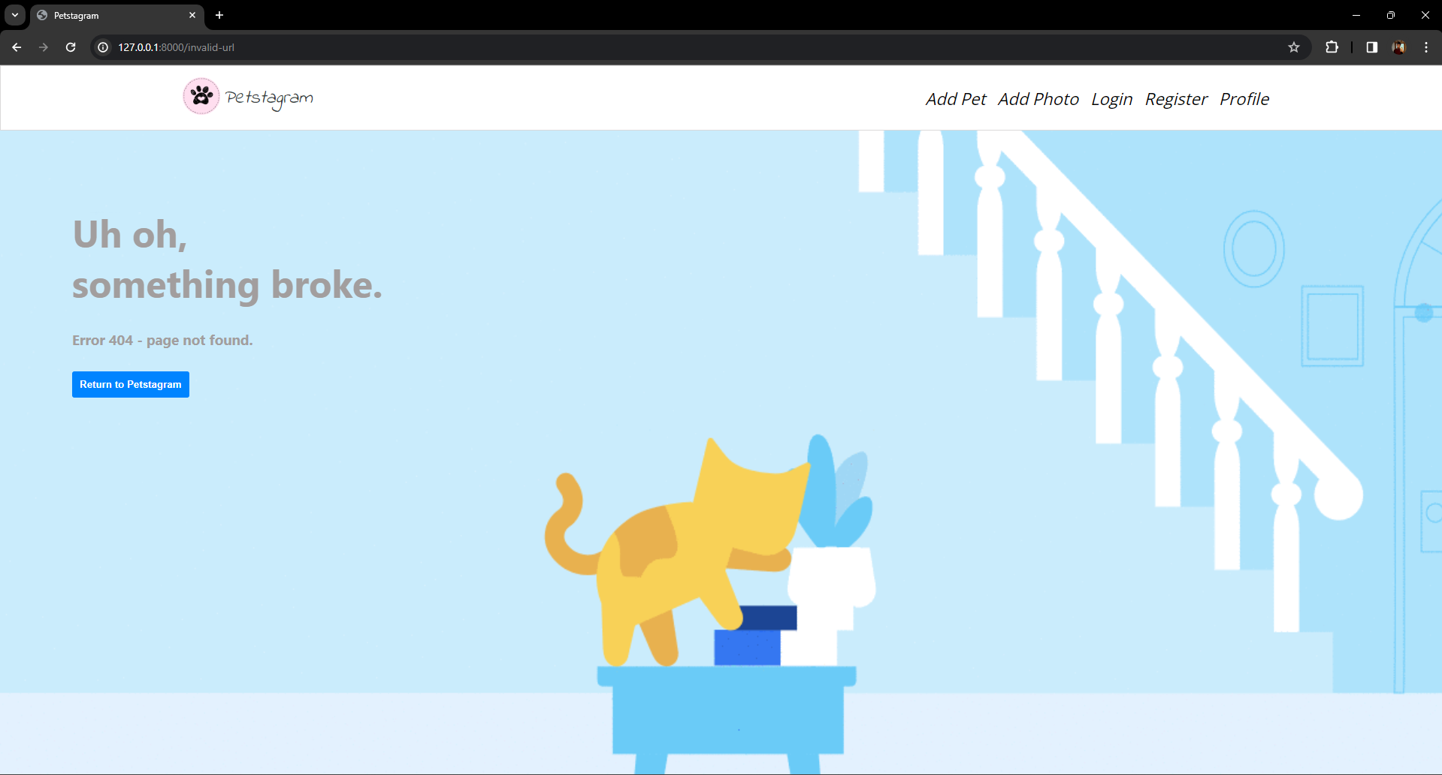

Workshop - Part 1.4

Creating the Pet Model
Let us start by creating the Pet model.
The fields Name and Pet Photo are required:
- Name - it should consist of a maximum of 30 characters.
- Personal Pet Photo - the user can link a picture using a URL.
The field date of birth is optional:
- Date of Birth - pet's day, month, and year of birth.
Open the pets/models.py file. There should be created one more field that will be auto populated with the following information:
- Slug - a slug automatically generated using the pet's name and the pet's id, separated by a "-" (dash).
The slug is part of the URL and as you know each URL should be unique:
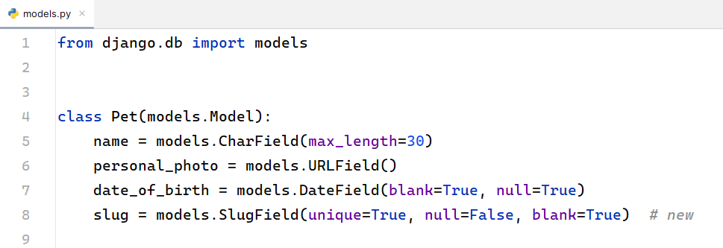

Django Admin Site
Let us now work more with the model in the Django admin interface. First, open the "pets/admin.py" file and register the model on the admin site. Now, start the development server, go to the admin site at http://127.0.0.1:8000/admin/, and log in with the credentials. As we logged in, we could see all registered models. The one we need is Pets. Let us add a new pet. We can create a pet successfully. However, the slug field is not auto populated:
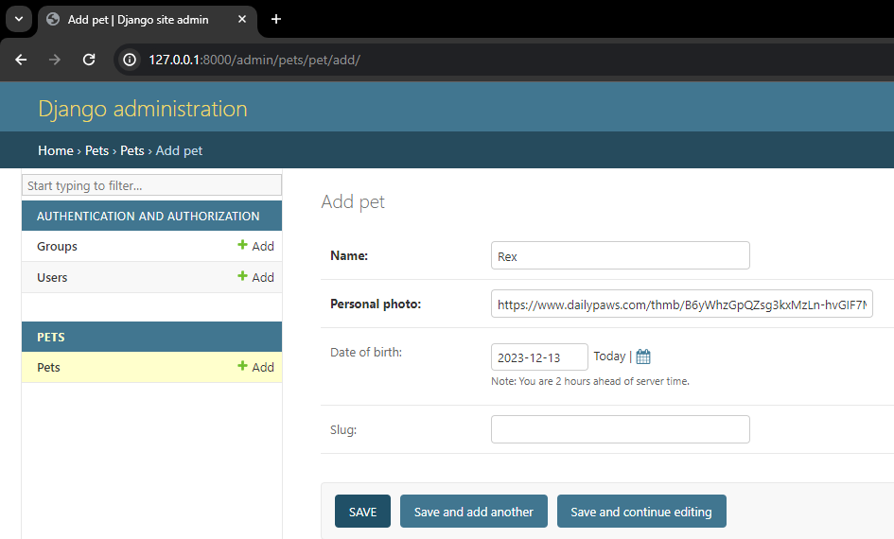
To do that, we will override the Pet model "save()" method using a special function called "slugify()" which helps us structure a slug from a given value. The if-statement stands to say that the slug field will NOT be changed when the name of the pet is changed: 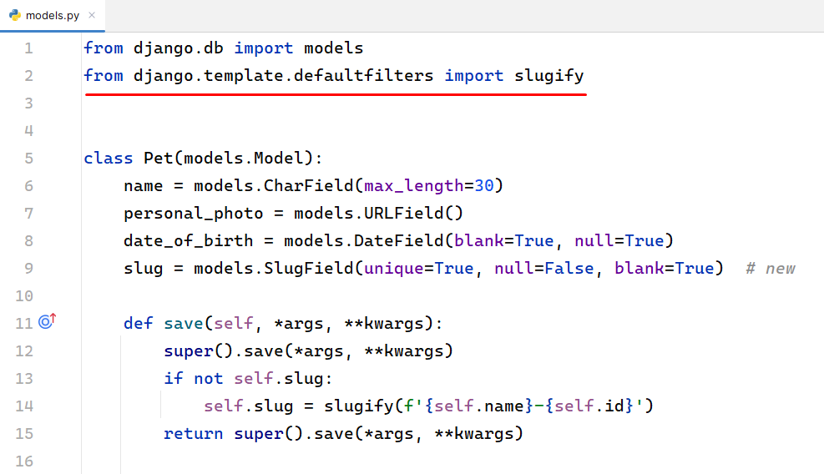
We can go further and change the slug field to be non-editable. This way we ensure that the field will NOT be changed either in the form or the admin site:
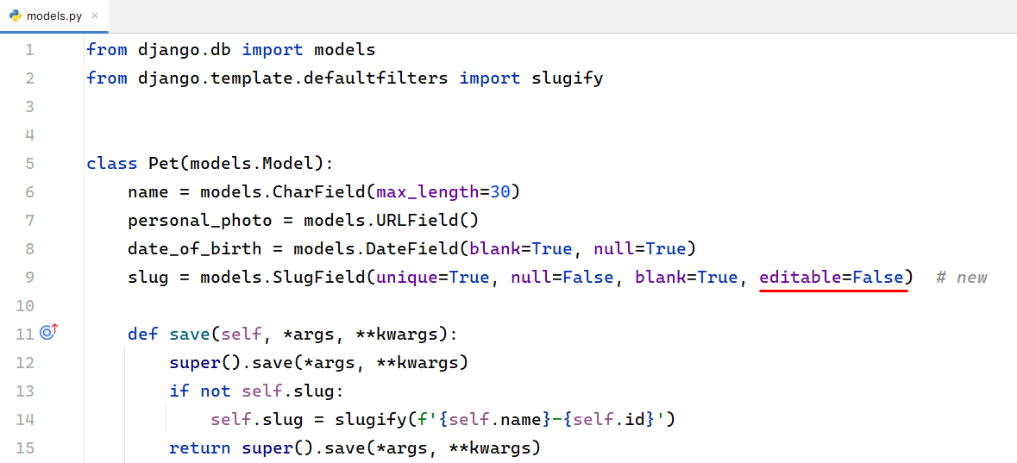
Now, we can improve the admin site interface by visualizing the pet models in a human-readable way. Up until now, each pet looks like a "Pet object" with an id. A thing we could do to ease the work of the administrators of the app is to show each pet by its name. Let us open the pets/admin.py file again and add a list_display option:
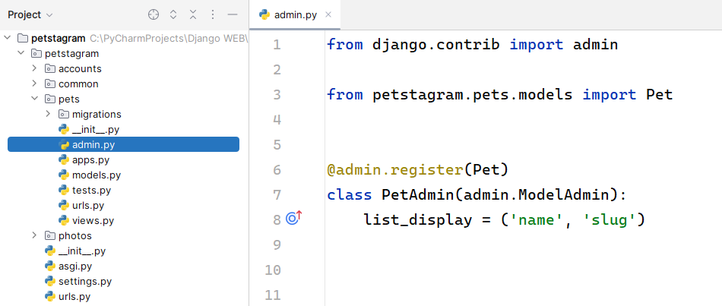
The admin interface changed like this: 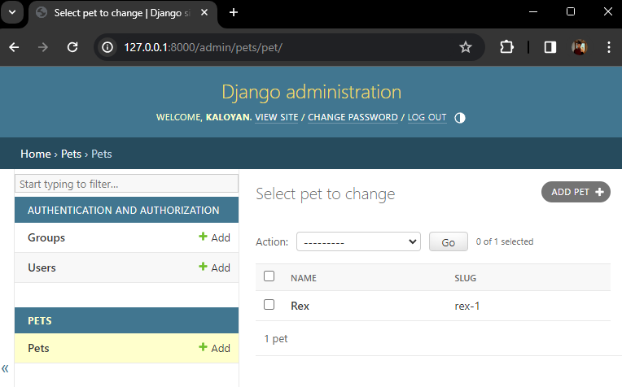

Creating the Photo Model
Note: there are some new features that will be discussed in the next lessons.
It is time to create the second model for the pet's photo.
The field Photo is required:
- Photo - the user can upload a picture from storage, the maximum size of the photo can be 5MB.
The fields description and tagged pets are optional:
- Description - a user can write any description of the photo; it should consist of a maximum of 300 characters and a minimum of 10 characters.
- Location - it should consist of a maximum of 30 characters.
- Tagged Pets - the user can tag none, one, or many of all pets. There is no limit on the number of tagged pets.
There should be created one more field that will be automatically generated:
- Date of publication - when a picture is added or edited, the date of publication is automatically generated.
Open the photos/models.py file and let us create the model:
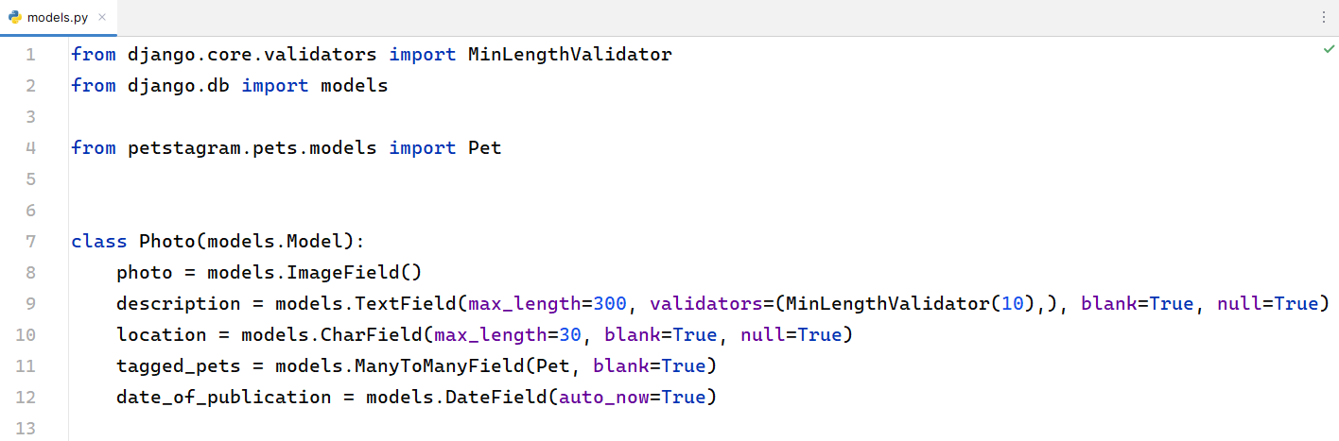
To work with an image field, we should install a library called Pillow:
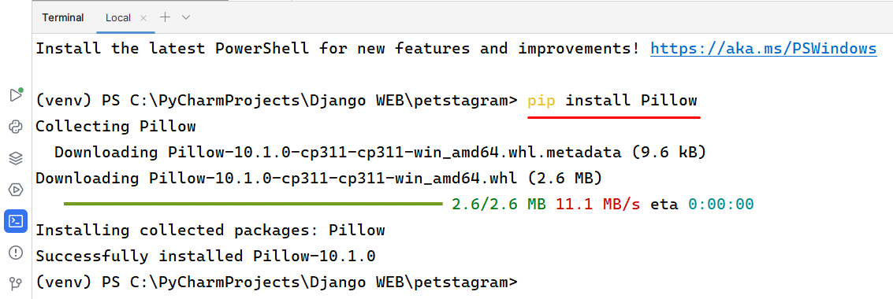
Note that the photo field has additional validation for a maximum size of 5MB. We should create a custom validator to validate the requirement. Let us create a new "validators.py" file in the "photos" app:
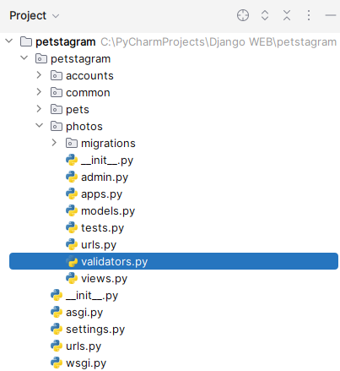
Open the file and write the validation function that will check if the photo size is above 5MB. In this case, it will raise a ValidationError:
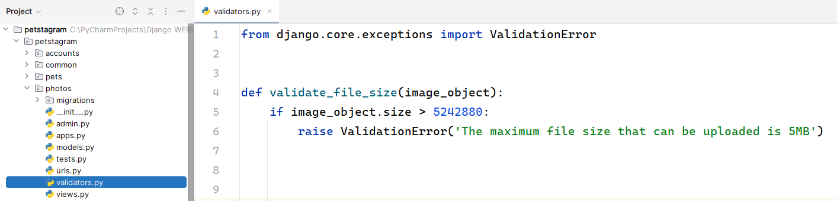
Then, we will add the validator to our validators list in the photo field:
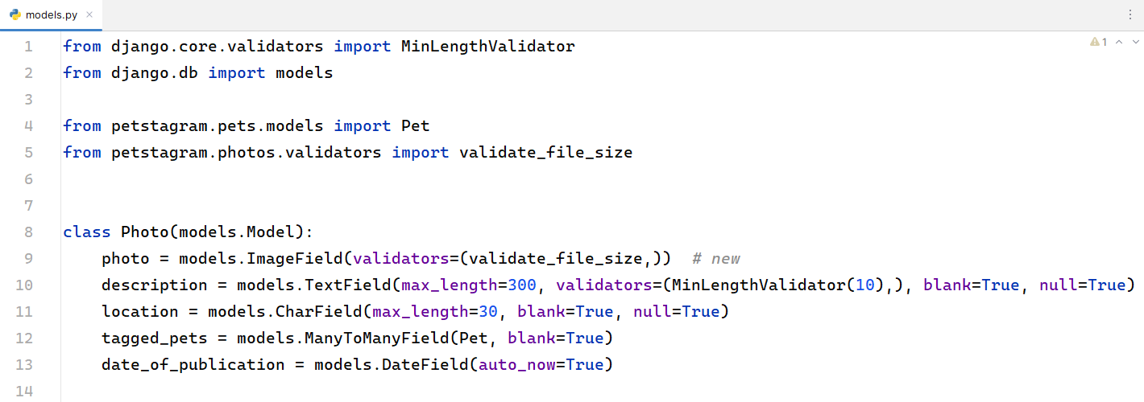
Make migration files and migrate the changes to the database. Register the model in the admin. Then, start the development server and check if everything works correctly in the admin panel. We can see that the pets in the tagged pets section visualize as pet objects with an id. We can change this by overriding the __str__ method in the Pet model:
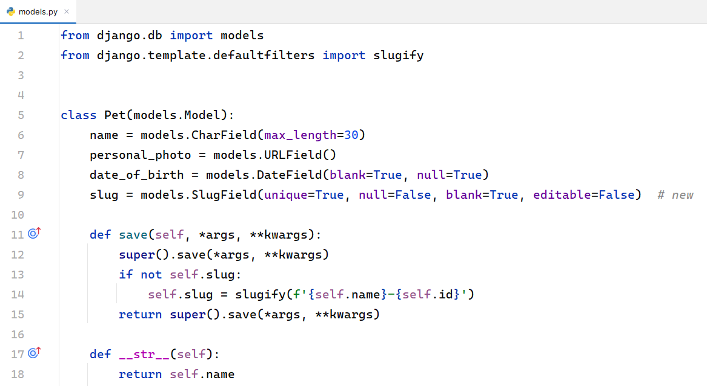
When we reload the add photo page in the admin site we will see the difference:
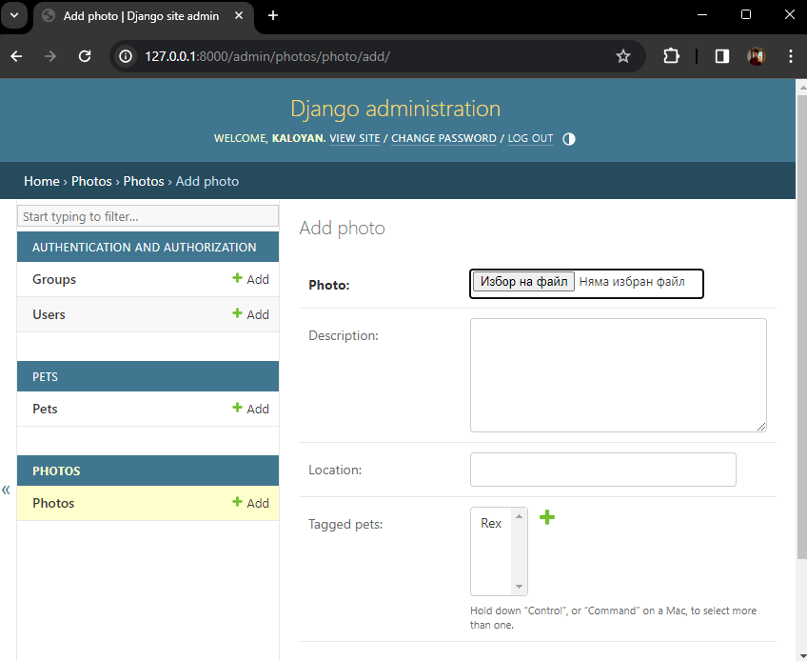
Now, it is time to customize the admin site interface on the photos model page. Let us add a list of fields to be displayed on the photo model's page. The fields are the id of the photo, date of publication, description, and names of all tagged pets. We cannot list a Many-to-Many field, but we can list the result of a function that gets all objects from a Many-to-Many field and concatenate their names in a string:
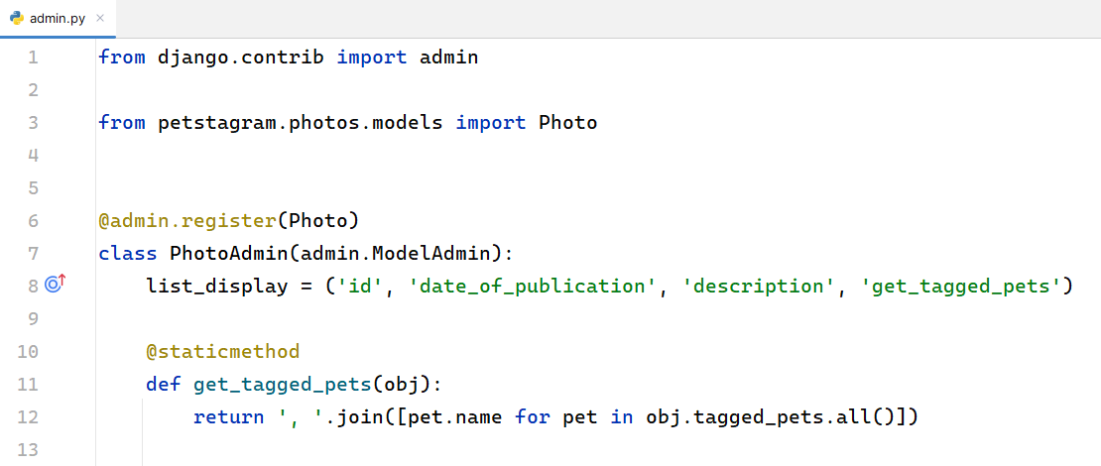
Now the interface looks like that:
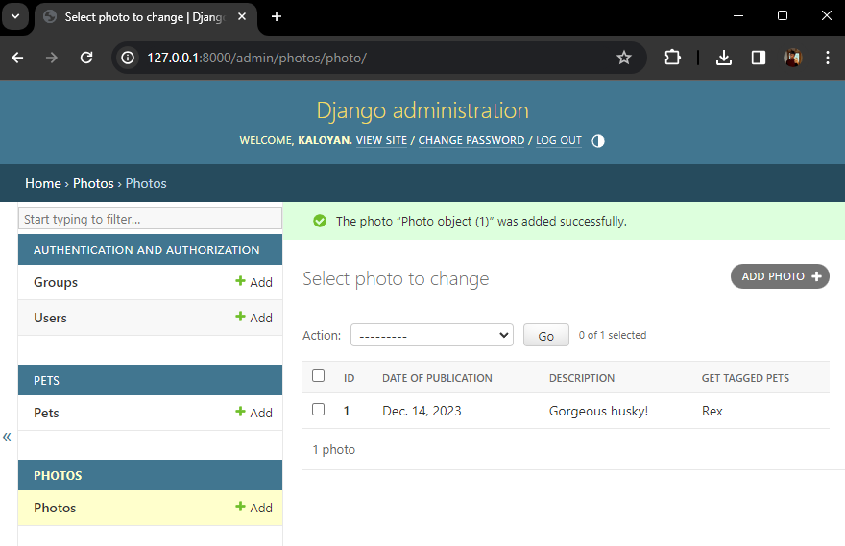

Creating the Comment Model
It is time to create the comment model.
The field Comment Text is required:
- Comment Text - it should consist of a maximum of 300 characters.
An additional field should be created:
- Date and Time of Publication - when a comment is created (only), the date of publication is automatically generated.
One more thing we should keep in mind is that the comment should relate to the photo (as in social apps users comment on a specific photo/post, i.e., the comment object is always connected to the photo object).
Open the common/models.py file and let us create the model:
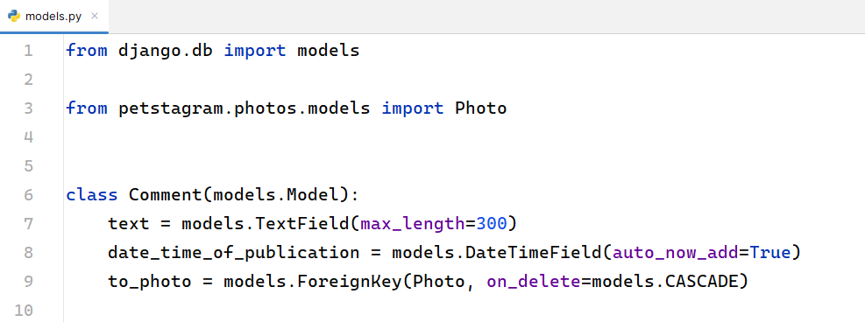

Creating the Like Model
Finally, create the Like model which should connect one photo to one user. However, we do not have a user object, so we will just create the model and add the photo relation:
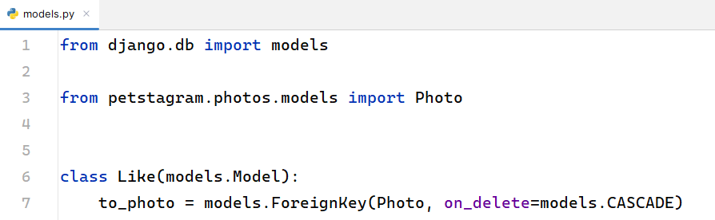
Make the migration files and migrate the changes to the database. We can now register the models in the Django admin site and check if they work correctly.

